Typical file location of gm_materials.xml file to swap (may be in different location at some suppliers):
C: or R:\data\cadsite\nx2007\nxcp\nxcp_2007a8\materials
**current version of NXCP is 2007a8
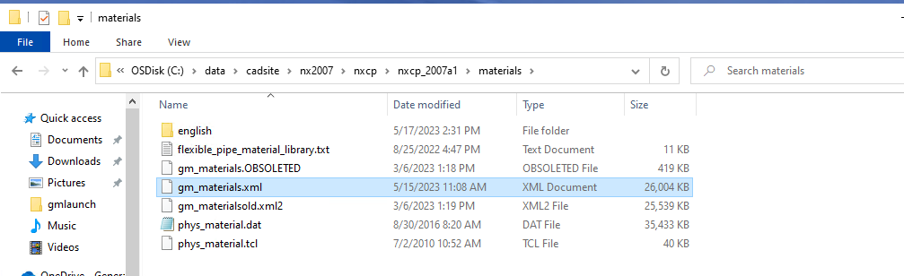
Before updating gm_materials.xml After updating gm_materials.xml
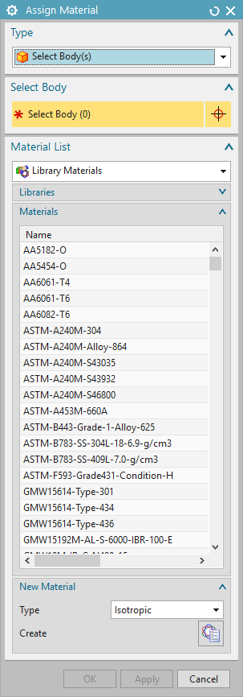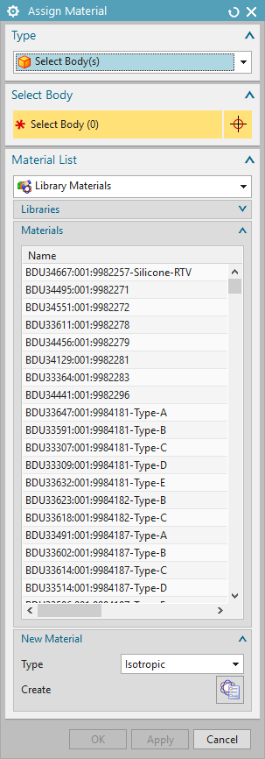

To assist with validating the swap. We have added a sample file named “BDU66635:073:Non_Std_PDM_Flat_File_001”. After you load the new IMM file, you should be able to locate this sample material. If you do not see the updated materials, please click the refresh button (left of the “x”) in the “Assign Materials” window.

